Java FTP CLIENT

Contents

- Abstract
- Existing System
- Proposed System
- Company Profile
- SRS ( Software Requirement Specification)
- Overview of Object Orineted Concepts and Java
- Design
- DFD Diagrams

About the software selected

- Terminology

- Design Implementation
- Output
- Bibliography
- Appendix

ABSTRACT:
In the Current Scenario of Information Representation one need a mechanism of Data Transfer as fast as possible in a secure manner across Internet and to do this one can make use of FTP . FTP, or File Transfer Protocol, lets users download files from another computer system on the Internet, or on a local network. Users can also transfer their own files to other computer systems after being authenticated . Some common uses of FTP include getting software from public sites and transferring work or school assignments completed at home. Downloading files often requires some knowledge of compression techniques. Many files are compressed--made smaller--so that they download faster. After downloading a compressed file, the user needs a software utility to uncompress the file. Some popular compression utilities include winzip , pkzip, sit, and binhex. This project implements the idea of an FTP server where the client connects to the server on a particular port, makes requests and utilizes the services of the server.

EXISTING SYSTEM:

The current techniques to transfer data include the Windows built-in features and also the traditional HTTP.

Although Windows provides good transfer capabilities, it supports only intranet data transfer rather than transfer of data across the internet because it uses a customary protocol which is not supported on Internet.
HTTP protocol on the other hand is considered to be vary ineffective as it is a stateless protocol. Due to this reason it turns out to be a resource consuming technique.
It is also insecure in the sense that it doesn’t require any user authentication prior to sharing of data.

PROPOSED SYSTEM:

As a solution to this problem RFC 959 was proposed by J. Postel and J. Reynolds to Network Working Group on October 1985 and later FTP has been standardized as a common mechanism to transfer files across internet .

The advantages of FTP are
1) To promote sharing of files (computer programs and/or data) across the internet.
2) To encourage indirect or implicit (via programs) use of remote computers.
3) To shield a user from variations in file storage systems among hosts, and
4) To transfer data reliably and efficiently. FTP, though usable directly by a user at a
terminal, is designed mainly for use by programs.

COMPANY PROFILE:

GALAXY SOFTWARE SOLUTIONS
Galaxy Software Solutions(GSS) is a IT Solution Provider for a dynamic environment where business and technology strategies converge. Our approach focuses on new ways of business combining IT innovation and adoption while also leveraging an organization's current IT assets. We work with large global corporations and new generation technology companies - to build new products or services and to implement prudent business and technology strategies in today's environment.

Galaxy's range of expertise includes:
- Software Development Services
- Engineering Services
- Systems Integration
- Customer Relationship Management
- Supply Chain Management
- Product Development
- Electronic Commerce
- Consulting
- IT Outsourcing

We apply technology with innovation and responsibility to achieve two broad objectives:

- Effectively address the business issues our customers face today
- Generate new opportunities that will help them stay ahead in the future

This approach rests on:
- A strategy where we Architect, Integrate and Manage technology services and solutions — we call it AIM for success.
- A robust offshore development methodology and reduced demand on customer resources
- A focus on the use of reusable frameworks to provide cost and time benefits

We combine the best people, processes and technology to achieve excellent results — consistently. We offer customers the advantages of:
Speed : We understand the importance of timing, of getting there before the competition. A rich portfolio of reusable, modular frameworks helps jump-start projects. Tried and tested methodology ensures that we follow a predictable, low-risk path to achieve results. Our track record is testimony to complex projects delivered within and even before schedule.

Expertise : Our teams combine cutting edge technology skills with rich domain expertise. What's equally important — we share a strong customer orientation that means we actually start by listening to the customer. We're focused on coming up with solutions that serve customer requirements today and anticipate future needs.
A Full Service Portfolio : We offer customers the advantage of being able to Architect, Integrate and Manage technology services. This means that they can rely on one, fully accountable source instead of trying to integrate disparate multi-vendor solutions.
Services :
GSS is providing its services to Sain medicaments Pvt. Ltd, Grace drugs and pharmaceuticals pvt ltd alka drugs and pharmaceuticals pvt ltd to name just a few with out rich experience and expertise in Information Technology we are in the best position to provide software solutions to distinct business requirements.

SRS (SOFTWARE REQUIREMENT SPECIFICATION)

THE FTP MODEL

-------------
|/---------\|
|| User || --------
||Interface|<--->| User |
|\----^----/| --------
---------- | | |
|/------\| FTP Commands |/----V----\|
||Server|<---------------->| User ||
|| PI || FTP Replies || PI ||
|\--^---/| |\----^----/|
| | | | | |
-------- |/--V---\| Data |/----V----\| --------
| File |<--->|Server|<---------------->| User |<--->| File |
|System| || DTP || Connection || DTP || |System|
-------- |\------/| |\---------/| --------
---------- -------------

Server-FTP USER-FTP
-------------

1. The data connection may be used in either direction.

2. The data connection need not exist all of the time.

3. Server-DTP
The data transfer process, in its normal "active" state, establishes the data connection with the "listening" data port. It sets up parameters for transfer and storage, and transfers data on command from its PI. The DTP can be placed in a "passive" state to listen for, rather than initiate a connection on the data port.

4. Server-FTP process
A process or set of processes which perform the function of file transfer in cooperation with a user-FTP process and, possibly, another server. The functions consist of a protocol interpreter (PI) and a data transfer process (DTP).

5. Server-PI
The server protocol interpreter "listens" on Port L for a connection from a user-PI and establishes a control communication connection. It receives standard FTP commands from the user-PI, sends replies, and governs the server-DTP.

6. User-DTP
The data transfer process "listens" on the data port for a connection from a server-FTP process. If two servers are transferring data between them, the user-DTP is inactive.

7. User-FTP process
A set of functions including a protocol interpreter, a data transfer process and a user interface which together perform the function of file transfer in cooperation with one or more server-FTP processes. The user interface allows a local language to be used in the command-reply dialogue with the user.

8. User-PI
The user protocol interpreter initiates the control connection from its port U to the server-FTP process, initiates FTP commands, and governs the user-DTP if that process is part of the file transfer.
An FTP (file transport protocol) server basically serves as a file repository which the client can query, place files on it and can also download files from it.

For this purpose the client has to have prior information of the IP address of the server and also the port on which it is listening for requests. When a particular client attempts to connect to the server , it creates a separate process to handle the client. This process is same for every incoming client. This enables the server to server multiple clients simultaneously. After a separate process is started, the client then supplies the authentication scheme to the server. The server then returns a welcome message to the client indicating that the initial hand shaking has been successful. On the other hand if the authentication scheme has failed at the server then the server returns an error code after which the client is simply disconnected.

After successfully receiving a client connection, the server then proceeds to setup the user directory which the user will be using for either querying the contents, storing file or retrieving files. The server also assigns appropriate privileges & security to the client directory also called user directory.

Every FTP server has a directory by default though not mandatory called as PUB directory which is meant for anonymous users. After this process the client then proceeds to make the requests. The requests that a client can make to the server can be categorized into 3 types.

1. Access Control Commands.
2. Transfer Parameter Commands
3. FTP Service Commands.

The Proposed System should provide the following features

ACCESS CONTROL COMMANDS
The following commands specify access control identifiers and they are typically used to authorize and authenticate the Client. (command codes are shown in parentheses)
USER NAME (USER)
The user identification is that which is required by the server for access to its file system. This command will normally be the first command transmitted by the user after the control connections are made (some servers may require this).
PASSWORD (PASS)
This command must be immediately preceded by the user name command, and, for some sites, completes the user's identification for access control. Since password information is quite sensitive, it is desirable in general to "mask" it or suppress typeout.

CHANGE WORKING DIRECTORY (CWD)
This command allows the user to work with a different directory or dataset for file storage or retrieval without altering his login or accounting information. Transfer parameters are similarly unchanged. The argument is a pathname specifying a directory or other system dependent file group designator.
CHANGE TO PARENT DIRECTORY (CDUP)
This command is a special case of CWD, and is included to simplify the implementation of programs for transferring directory trees between operating systems having different syntaxes for naming the parent directory.
REINITIALIZE (REIN)
This command terminates a USER, flushing all I/O and account information, except to allow any transfer in progress to be completed.
LOGOUT (QUIT)
This command terminates a USER and if file transfer is not in progress, the server closes the control connection. If file transfer is in progress, the connection will remain open for result response and the server will then close it. An unexpected close on the control connection will cause the server to take the effective action of logout (QUIT).

TRANSFER PARAMETER COMMANDS
Data transfer parameters have default values, and the commands specifying data transfer parameters are required only if the default parameter values are to be changed. The default value is the last specified value, or if no value has been specified, the standard default value is as stated here. This implies that the server must "remember" the applicable default values. The commands may be in any order except that they must precede the FTP service request. The following commands specify data transfer parameters: (command codes are shown in parentheses) .
DATA PORT (PORT)
The argument is a HOST-PORT specification for the data port to be used in data connection. There are defaults for both the user and server data ports, and under normal circumstances this command and its reply are not needed. If this command is used, the argument is the concatenation of a 32-bit internet host address and a 16-bit TCP port address. This address information is broken into 8-bit fields and the value of each field is transmitted as a decimal number (in character string representation). The fields are separated by commas. A port command would be:
Ex ..(HostName is 100.100.100.1 and the port of DataConnection is 1000) PORT 100,100,100,1,3,232
PASSIVE (PASV)
This command requests the server-DTP to "listen" on a data port (which is not its default data port) and to wait for a connection rather than initiate one upon receipt of a transfer command. The response to this command includes the host and port address this server is listening on.
REPRESENTATION TYPE (TYPE)
This command specifies how to Initiate Data Transfer ( in Text or Binary)
Ex…. TYPE I or TYPE A

FTP SERVICE COMMANDS
The FTP service commands define the file transfer or the file system function requested by the user. The argument of an FTP service command will normally be a pathname. The syntax of pathnames must conform to server site conventions (with standard defaults applicable), and the language conventions of the control connection. The suggested default handling is to use the last specified device, directory or file name, or the standard default defined for local users. The commands may be in any order except that a "rename from" command must be followed by a "rename to" command and the restart command must be followed by the interrupted service command (e.g., STOR or RETR). The data, when transferred in response to FTP service commands, shall always be sent over the data connection, except for certain informative replies. The following commands specify FTP service requests:
RETRIEVE (RETR)
This command causes the server-DTP to transfer a copy of the file, specified in the pathname, to the client at the other end of the data connection. The status and contents of the file at the server site shall be unaffected i.e. To get a File form Server to Client
STORE (STOR)
This command causes the server-DTP to accept the data transferred via the data connection and to store the data as a file at the server site. If the file specified in the pathname exists at the server site, then its contents shall be replaced by the data being transferred. A new file is created at the server site if the file specified in the pathname does not already exist. i.e. To transfer a file from client to Server.

STORE UNIQUE (STOU)
This command behaves like STOR except that the resultant file is to be created in the current directory under a name unique to that directory. The 250 Transfer Started response must include the name generated.
APPEND (APPE)
This command causes the server-DTP to accept the data transferred via the data connection and to store the data in a file at the server site. If the file specified in the pathname exists at the server site, then the data shall be appended to that file; otherwise the file specified in the pathname shall be created at the server site.
RENAME FROM (RNFR)
This command specifies the old pathname of the file which is to be renamed. This command must be immediately followed by a "rename to" command specifying the new file pathname.
RENAME TO (RNTO)
This command specifies the new pathname of the file specified in the immediately preceding "rename from" command. Together the two commands cause a file to be renamed.
ABORT (ABOR)
This command tells the server to abort the previous FTP service command and any associated transfer of data. No action is to be taken if the previous command has been completed (including data transfer). The control connection is not to be closed by the server, but the data connection must be closed.

DELETE (DELE)
This command causes the file specified in the pathname to be deleted at the server site. If an extra level of protection is desired (such as the query, "Do you really wish to delete?"), it should be provided by the user-FTP process.
REMOVE DIRECTORY (RMD)
This command causes the directory specified in the pathname to be removed as a directory (if the pathname is absolute) or as a subdirectory of the current working directory (if the pathname is relative).
MAKE DIRECTORY (MKD)
This command causes the directory specified in the pathname to be created as a directory (if the pathname is absolute) or as a subdirectory of the current working directory (if the pathname is relative).
PRINT WORKING DIRECTORY (PWD)
This command causes the name of the current working directory to be returned in the reply.
LIST (LIST)
This command causes a list to be sent from the server to the passive DTP. If the pathname specifies a directory or other group of files, the server should transfer a list of files in the specified directory. If the pathname specifies a file then the server should send current information on the file. A null argument implies the user's current working or default directory.
NAME LIST (NLST)
This command causes a directory listing to be sent from server to user site. The pathname should specify a directory or other system-specific file group descriptor; a null argument implies the current directory. The server will return a stream of names of files and no other information.
SYSTEM (SYST)
This command is used to find out the type of operating system at the server.
STATUS (STAT)
This command shall cause a status response to be sent over the control connection in the form of a reply.
HELP (HELP)
This command shall cause the server to send helpful information regarding its implementation status over the control connection to the user. The command may take an argument (e.g., any command name) and return more specific information as a response.
NOOP (NOOP)
This command does not affect any parameters or previously entered commands. It specifies no action other than that the server send an OK reply.

Design and Implementation
The following are the FTP commands:
USER <SP> <username> <CRLF>
PASS <SP> <password> <CRLF>
ACCT <SP> <account-information> <CRLF>
CWD <SP> <pathname> <CRLF>
CDUP <CRLF>
SMNT <SP> <pathname> <CRLF>
QUIT <CRLF>
REIN <CRLF>
PORT <SP> <host-port> <CRLF>
PASV <CRLF>
TYPE <SP> <type-code> <CRLF>
STRU <SP> <structure-code> <CRLF>
MODE <SP> <mode-code> <CRLF>
RETR <SP> <pathname> <CRLF>
STOR <SP> <pathname> <CRLF>
STOU <CRLF>
APPE <SP> <pathname> <CRLF>
ALLO <SP> <decimal-integer>
[<SP> R <SP> <decimal-integer>] <CRLF>
REST <SP> <marker> <CRLF>
RNFR <SP> <pathname> <CRLF>
RNTO <SP> <pathname> <CRLF>
ABOR <CRLF>
DELE <SP> <pathname> <CRLF>
RMD <SP> <pathname> <CRLF>
MKD <SP> <pathname> <CRLF>
PWD <CRLF>
LIST [<SP> <pathname>] <CRLF>
NLST [<SP> <pathname>] <CRLF>
SITE <SP> <string> <CRLF>
SYST <CRLF>
STAT [<SP> <pathname>] <CRLF>
HELP [<SP> <string>] <CRLF>
NOOP <CRLF>

FTP COMMAND ARGUMENTS
The syntax of the above argument fields (using BNF notation where applicable) is:
<username> ::= <string>
<password> ::= <string>
<account-information> ::= <string>
<string> ::= <char> | <char><string>
<char> ::= any of the 128 ASCII characters except <CR> and
<LF>
<marker> ::= <pr-string>
<pr-string> ::= <pr-char> | <pr-char><pr-string>
<pr-char> ::= printable characters, any
ASCII code 33 through 126
<byte-size> ::= <number>
<host-port> ::= <host-number>,<port-number>
<host-number> ::= <number>,<number>,<number>,<number>
<port-number> ::= <number>,<number>
<number> ::= any decimal integer 1 through 255
<form-code> ::= N | T | C
<type-code> ::= A [<sp> <form-code>]
| E [<sp> <form-code>]
| I
| L <sp> <byte-size>
<structure-code> ::= F | R | P
<mode-code> ::= S | B | C
<pathname> ::= <string>
<decimal-integer> ::= any decimal integer

SEQUENCING OF COMMANDS AND REPLIES
The communication between the user and server is intended to be an alternating dialogue. As such, the user issues an FTP command and the server responds with a prompt primary reply. The user should wait for this initial primary success or failure response before sending further commands.
Certain commands require a second reply for which the user should also wait. These replies may, for example, report on the progress or completion of file transfer or the closing of the data connection. They are secondary replies to file transfer commands.
One important group of informational replies is the connection greetings. Under normal circumstances, a server will send a 220 reply, "awaiting input", when the connection is completed. The user should wait for this greeting message before sending any commands. If the server is unable to accept input right away, a 120 "expected delay" reply should be sent immediately and a 220 reply when ready. The user will then know not to hang up if there is a delay.
Spontaneous Replies
Sometimes "the system" spontaneously has a message to be sent to a user (usually all users). For example, "System going down in 15 minutes". There is no provision in FTP for such spontaneous information to be sent from the server to the user. It is recommended that such information be queued in the server-PI and delivered to the user-PI in the next reply (possibly making it a multi-line reply).
The table below lists alternative success and failure replies for each command. These must be strictly adhered to; a server may substitute text in the replies, but the meaning and action implied by the code numbers and by the specific command reply sequence cannot be altered.
Command-Reply Sequences
In this section, the command-reply sequence is presented. Each command is listed with its possible replies; command groups are listed together. Preliminary replies are listed first (with their succeeding replies indented and under them), then positive and negative completion, and finally intermediary replies with the remaining commands from the sequence following. This listing forms the basis for the state diagrams, which will be presented separately.
Connection Establishment
120
220
220
421
Login
USER
230
530
500, 501, 421
331, 332
PASS
230
202
530
500, 501, 503, 421
332
ACCT
230
202
530
500, 501, 503, 421
CWD
250
500, 501, 502, 421, 530, 550
CDUP
200
500, 501, 502, 421, 530, 550
SMNT
202, 250
500, 501, 502, 421, 530, 550
Logout
REIN
120
220
220
421
500, 502
QUIT
221
500

Transfer parameters
PORT
200
500, 501, 421, 530
PASV
227
500, 501, 502, 421, 530
MODE
200
500, 501, 504, 421, 530
TYPE
200
500, 501, 504, 421, 530
STRU
200
500, 501, 504, 421, 530
File action commands
ALLO
200
202
500, 501, 504, 421, 530
REST
500, 501, 502, 421, 530
350
STOR
125, 150
(110)
226, 250
425, 426, 451, 551, 552
532, 450, 452, 553
500, 501, 421, 530
STOU
125, 150
(110)
226, 250
425, 426, 451, 551, 552
532, 450, 452, 553
500, 501, 421, 530
RETR
125, 150
(110)
226, 250
425, 426, 451
450, 550
500, 501, 421, 530

LIST
125, 150
226, 250
425, 426, 451
450
500, 501, 502, 421, 530
NLST
125, 150
226, 250
425, 426, 451
450
500, 501, 502, 421, 530
APPE
125, 150
(110)
226, 250
425, 426, 451, 551, 552
532, 450, 550, 452, 553
500, 501, 502, 421, 530
RNFR
450, 550
500, 501, 502, 421, 530
350
RNTO
250
532, 553
500, 501, 502, 503, 421, 530
DELE
250
450, 550
500, 501, 502, 421, 530
RMD
250
500, 501, 502, 421, 530, 550
MKD
257
500, 501, 502, 421, 530, 550
PWD
257
500, 501, 502, 421, 550
ABOR
225, 226
500, 501, 502, 421

Informational commands
SYST
215
500, 501, 502, 421
STAT
211, 212, 213
450
500, 501, 502, 421, 530
HELP
211, 214
500, 501, 502, 421
Miscellaneous commands
SITE
200
202
500, 501, 530
NOOP
200
500 421

Security:
At the highest level, the FTP security extensions seek to provide an abstract mechanism for authenticating and/or authorizing connections, and integrity and/or confidentiality protecting commands, replies, and data transfers.

In the context of FTP security, authentication is the establishment of a client's identity and/or a server's identity in a secure way, usually using cryptographic techniques. The basic FTP protocol does not have a concept of authentication. Authorization is the process of validating a user for login. The basic authorization process involves the USER, PASS, and ACCT commands. With the FTP security extensions, authentication established using a security mechanism may also be used to make the authorization decision.

Without the security extensions, authentication of the client, as this term is usually understood, never happens. FTP authorization is accomplished with a password, passed on the network in the clear as the argument to the PASS command. The possessor of this password is assumed to be authorized to transfer files as the user named in the USER command, but the identity of the client is never securely established.
An FTP security interaction begins with a client telling the server what security mechanism it wants to use with the AUTH command. The server will either accept this mechanism, reject this mechanism, or, in the case of a server which does not implement the security extensions, reject the command completely. The client may try multiple security mechanisms until it requests one which the server accepts. This allows a rudimentary form of negotiation to take place. (If more complex negotiation is desired, this may be implemented as a security mechanism.) The server's reply will indicate if the client must respond with additional data for the security mechanism to interpret. If none is needed, this will usually mean that the mechanism is one where the password (specified by the PASS command) is to be interpreted differently, such as with a token or one-time password system.

If the server requires additional security information, then the client and server will enter into a security data exchange. The client will send an ADAT command containing the first block of security data. The server's reply will indicate if the data exchange is complete, if there was an error, or if more data is needed. The server's reply can optionally contain security data for the client to interpret. If more data is needed, the client will send another ADAT command containing the next block of data, and await the server's reply. This exchange can continue as many times as necessary. Once this exchange completes, the client and server have established a Security association. This security association may include authentication (client, server, or mutual) and keying information for integrity and/or confidentiality, depending on the mechanism in use.

The term "security data" here is carefully chosen. The purpose of the security data exchange is to establish a security association, which might not actually include any authentication at all, between the client and the server as described above. For instance, a Diffie-Hellman exchange establishes a secret key, but no authentication takes place. If an FTP server has an RSA key pair but the client does not, then the client can authenticate the server, but the server cannot authenticate the client. Once a security association is established, authentication which is a part of this association may be used instead of or in addition to the standard username/password exchange for authorizing a user to connect to the server. A username specified by the USER command is always required to specify the identity to be used on the server.

In order to prevent an attacker from inserting or deleting commands on the control stream, if the security association supports integrity, then the server and client must use integrity protection on the control stream, unless it first transmits a CCC command to turn off this requirement. Integrity protection is performed with the MIC and ENC commands, and the 63z reply codes. The CCC command and its reply must be transmitted with integrity protection. Commands and replies may be transmitted without integrity (that is, in the clear or with confidentiality only) only if no security association is established, the negotiated security association does not support integrity, or the CCC command has succeeded.Once the client and server have negotiated with the PBSZ command an acceptable buffer size for encapsulating protected data over the data channel, the security mechanism may also be used to protect data channel transfers.

Policy is not specified by this document. In particular, client and server implementations may choose to implement restrictions on what operations can be performed depending on the security association which exists. For example, a server may require that a client authorize via a security mechanism rather than using a password, require that the client provide a one-time password from a token, require at least integrity protection on the command channel, or require that certain files only be transmitted encrypted. An anonymous ftp client might refuse to do file transfers without integrity protection in order to insure the validity of files downloaded.

No particular set of functionality is required, except as dependencies described in the next section. This means that none of authentication, integrity, or confidentiality are required of an implementation, although a mechanism which does none of these is not of much use. For example, it is acceptable for a mechanism to implement only integrity protection, one-way authentication and/or encryption, encryption without any authentication or integrity protection, or any other subset of functionality if policy or technical considerations make this desirable. Of course, one peer might require as a matter of policy stronger protection than the other is able to provide, preventing perfect interoperability.

STATE DIAGRAMS
Here we present state diagrams for a very simple minded FTP implementation. Only the first digit of the reply codes is used. There is one state diagram for each group of FTP commands or command sequences.
The command groupings were determined by constructing a model for each command then collecting together the commands with structurally identical models.
For each command or command sequence there are three possible outcomes: success (S), failure (F), and error (E). In the state diagrams below we use the symbol B for "begin", and the symbol W for "wait for reply".
We first present the diagram that represents the largest group of FTP commands:

1,3 +---+
----------->| E |
| +---+
|
+---+ cmd +---+ 2 +---+
| B |---------->| W |---------->| S |
+---+ +---+ +---+
|
| 4,5 +---+
----------->| F |
+---+

This diagram models the commands:
ABOR, ALLO, DELE, CWD, CDUP, SMNT, HELP, MODE, NOOP, PASV,
QUIT, SITE, PORT, SYST, STAT, RMD, MKD, PWD, STRU, and TYPE.

The other large group of commands is represented by a very similar diagram:

3 +---+
----------->| E |
| +---+
|
+---+ cmd +---+ 2 +---+
| B |---------->| W |---------->| S |
+---+ --->+---+ +---+
| | |
| | | 4,5 +---+
| 1 | ----------->| F |
----- +---+
This diagram models the commands:
APPE, LIST, NLST, REIN, RETR, STOR, and STOU.
Note that this second model could also be used to represent the first group of commands, the only difference being that in the first group the 100 series replies are unexpected and therefore treated as error, while the second group expects (some may require) 100 series replies. Remember that at most, one 100 series reply is allowed per command.
The remaining diagrams model command sequences, perhaps the simplest of these is the rename sequence:

+---+ RNFR +---+ 1,2 +---+
| B |---------->| W |---------->| E |
+---+ +---+ -->+---+
| | |
3 | | 4,5 |
-------------- ------ |
| | | +---+
| ------------->| S |
| | 1,3 | | +---+
| 2| --------
| | | |
V | | |
+---+ RNTO +---+ 4,5 ----->+---+
| |---------->| W |---------->| F |
+---+ +---+ +---+

The next diagram is a simple model of the Restart command:

+---+ REST +---+ 1,2 +---+
| B |---------->| W |---------->| E |
+---+ +---+ -->+---+
| | |
3 | | 4,5 |
-------------- ------ |
| | | +---+
| ------------->| S |
| | 3 | | +---+
| 2| --------
| | | |
V | | |
+---+ cmd +---+ 4,5 ----->+---+
| |---------->| W |---------->| F |
+---+ -->+---+ +---+
| |
| 1 |
------

Where "cmd" is APPE, STOR, or RETR.
We note that the above three models are similar. The Restart differs from the Rename two only in the treatment of 100 series replies at the second stage, while the second group expects (some may require) 100 series replies. Remember that at most, one 100 series reply is allowed per command.
The most complicated diagram is for the Login sequence:

1
+---+ USER +---+------------->+---+
| B |---------->| W | 2 ---->| E |
+---+ +---+------ | -->+---+
| | | | |
3 | | 4,5 | | |
-------------- ----- | | |
| | | | |
| | | | |
| --------- |
| 1| | | |
V | | | |
+---+ PASS +---+ 2 | ------>+---+
| |---------->| W |------------->| S |
+---+ +---+ ---------->+---+
| | | | |
3 | |4,5| | |
-------------- -------- |
| | | | |
| | | | |
| -----------
| 1,3| | | |
V | 2| | |
+---+ ACCT +---+-- | ----->+---+
| |---------->| W | 4,5 -------->| F |
+---+ +---+------------->+---+

Finally, we present a generalized diagram that could be used to model the command and reply interchange:

------------------------------------
| |
Begin | |
| V |
| +---+ cmd +---+ 2 +---+ |
-->| |------->| |---------->| | |
| | | W | | S |-----|
-->| | -->| |----- | | |
| +---+ | +---+ 4,5 | +---+ |
| | | | | | |
| | | 1| |3 | +---+ |
| | | | | | | | |
| | ---- | ---->| F |-----
| | | | |
| | | +---+
-------------------
|
|
V
End

The need for FTP to support page structure derives principally from the need to support efficient transmission of files between TOPS-20 systems, particularly the files used by NLS.
The file system of TOPS-20 is based on the concept of pages. The operating system is most efficient at manipulating files as pages. The operating system provides an interface to the file system so that many applications view files as sequential streams of characters. However, a few applications use the underlying page structures directly, and some of these create holey files.
A TOPS-20 disk file consists of four things: a pathname, a page table, a (possibly empty) set of pages, and a set of attributes.
The pathname is specified in the RETR or STOR command. It includes the directory name, file name, file name extension, and generation number.
The page table contains up to 2**18 entries. Each entry may be EMPTY, or may point to a page. If it is not empty, there are also some page-specific access bits; not all pages of a file need have the same access protection.
A page is a contiguous set of 512 words of 36 bits each.
The attributes of the file, in the File Descriptor Block (FDB), contain such things as creation time, write time, read time, writer's byte-size, end-of-file pointer, count of reads and writes, backup system tape numbers, etc.
Note that there is NO requirement that entries in the page table be contiguous. There may be empty page table slots between occupied ones. Also, the end of file pointer is simply a number. There is no requirement that it in fact point at the "last" datum in the file. Ordinary sequential I/O calls in TOPS-20 will cause the end of file pointer to be left after the last datum written, but other operations may cause it not to be so, if a particular programming system so requires.
In fact, in both of these special cases, "holey" files and end-of-file pointers NOT at the end of the file, occur with NLS data files.
The TOPS-20 paged files can be sent with the FTP transfer parameters: TYPE L 36, STRU P, and MODE S (in fact, any mode could be used).
Each page of information has a header. Each header field, which is a logical byte, is a TOPS-20 word, since the TYPE is L 36.
The header fields are:
Word 0: Header Length.
The header length is 5.
Word 1: Page Index.
If the data is a disk file page, this is the number of that page in the file's page map. Empty pages (holes) in the file are simply not sent. Note that a hole is NOT the same as a page of zeros.
Word 2: Data Length.
The number of data words in this page, following the header. Thus, the total length of the transmission unit is the Header Length plus the Data Length.
Word 3: Page Type.
A code for what type of chunk this is. A data page is type 3, the FDB page is type 2.
Word 4: Page Access Control.
The access bits associated with the page in the file's page map. (This full word quantity is put into AC2 of an SPACS by the program reading from net to disk.)
After the header are Data Length data words. Data Length is currently either 512 for a data page or 31 for an FDB. Trailing zeros in a disk file page may be discarded, making Data Length less than 512 in that case.

DATA FLOW DIAGRAMS:

CONTEXT LEVEL DFD
Client
Client

FTP Services

Request Service

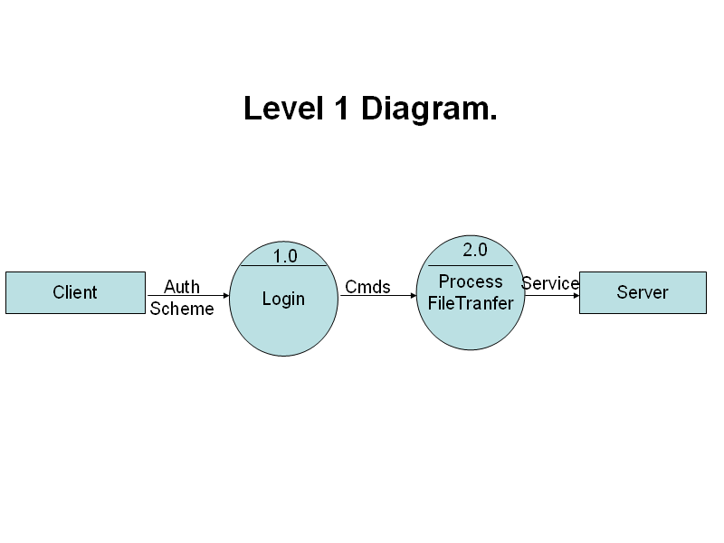

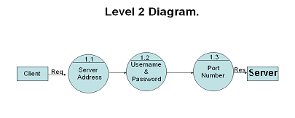

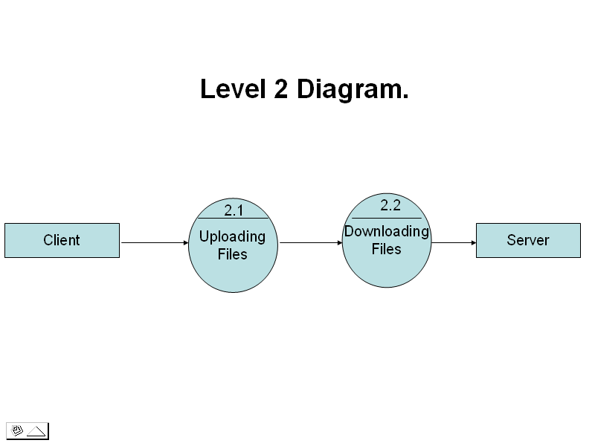

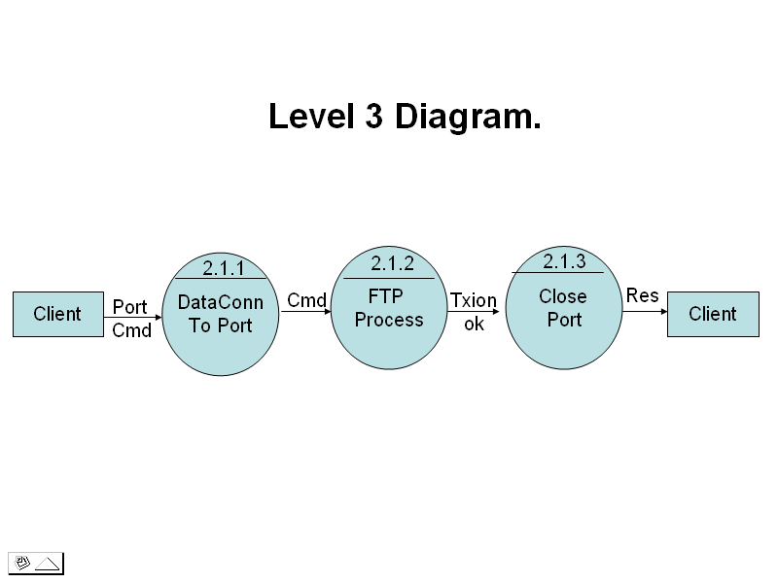

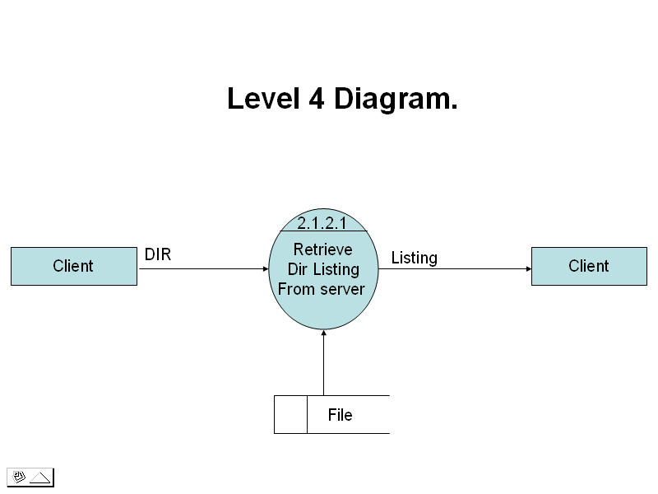

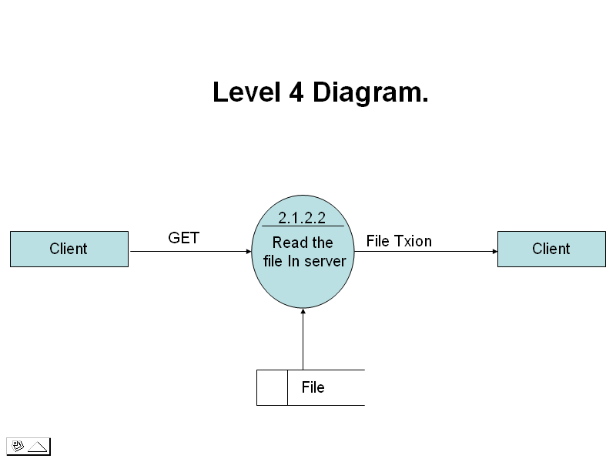

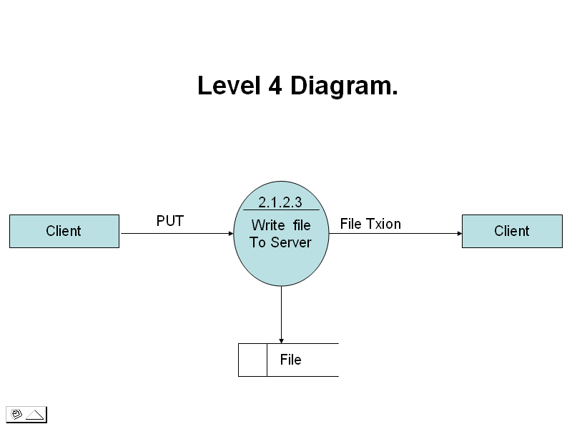

OBJECT ORIENTED PROGRAMMING AND Java

Object-oriented Programming was developed because limitations were discovered in earlier approaches to programming. To appreciate what OOP does, we need to understand what these limitations are and how they arose from traditional programming.

PROCEDURAL LANGUAGES
Pascal, C, Basic, Fortran, and similar languages are procedural languages. That is, each statement in the language tells the computer to do something: Get some input, add these numbers, divide by 6, display the output. A program in a procedural languages is a list of instructions.
For very small programs no other organizing principle(often called a paradigm) is needed. The programmer creates the list of instructions , and the computer carries them out.
Division into Functions
When programs become larger, a single list of instructions becomes unwieldy. Few programmers can comprehend a program of more than a few hundred statements unless it is broken down into smaller units. For this reason the function was adopted as a way to make programs more comprehensible to their human creators. (The term functions is used in C++ and C. In other languages the same concept may be referred to as a subroutine, a subprogram, or a procedure.) A program is divided into functions, and (ideally, at least) each function has a clearly defined purpose and a clearly defined interface to the other functions in the program.

The idea of breaking a program into functions can be further extended by grouping a number of functions together into a larger entity called a module, but the principle is similar: grouping a number of components that carry out specific tasks.

Dividing a program into functions and modules is one of the cornerstones of structured programming, the somewhat loosely defined discipline that has influenced programming organization for more than a decade.

Problems with Structured Programming
As programs grow ever larger and more complex, even the structured programming approach begins to show signs of strain. You may have heard about, or been involved in, horror stories of program development. The project is too complex, the schedule slips, more programmers are added, complexity increases, costs skyrocket, the schedule slips further, and disaster ensues. (See The Mythical Man_month, by Fredrick P. Brooks, Jr., Addison-Wesley, 1982, for a vivid description of this process.)
Analyzing the reasons for these failures reveals that there are weaknesses in the procedural paradigm itself. No matter how well the structured programming approach is implemented, large programs become excessively complex.

What are the reasons for this failure of procedural languages? One of the most crucial is the role played by data.
Data Undervalued
In a procedural language, the emphasis is on doing things--read the keyboard, invert the vector, check for errors, and so on. The subdivision of a program into functions continues this emphasis. Functions do things just as single program statements do. What they do may be more complex or abstract, but the emphasis is still on the action.
What happens to the data in this paradigm? Data is, after all, the reason for a program's existence. The important part of an inventory program isn't a function that displays the data, or a function that checks for correct input; it's the inventory data itself. Yet data is given second-class status in the organization of procedural languages.
For example, in an inventory program, the data that makes up the inventory is probably read from a disk file into memory, where it is treated as a global variable. By global we mean that the variables that constitute the data are declared outside of any function, so they are accessible to all functions. These functions perform various operations on the data. They read it, analyze it, update it, rearrange it, display it, write it back to the disk, and so on.
We should note that most languages, such as Pascal and C, also support local variables, which are hidden within a single function. But local variables are not useful for important data that must be accessed by many different functions. Figure 1-1 shows the relationship between global and local variables.

Now suppose a new programmer is hired to write a function to analyze this inventory data in a certain way. Unfamiliar with the subtleties of the program, the programmer creates a function that accidentally corrupts the. This is easy to do, because every function has complete access to the data. It's like leaving your personal papers in the lobby of your apartment building: Anyone can change or destroy them. In the same way, global data can be corrupted by functions that have no business changing it.
Another problem is that, since many functions access the same data, the way the data is stored becomes critical. The arrangement of the data can't be changed without modifying all the functions that access it. If you add new data items, for example, you'll need to modify all the functions that access the data so that they can also access these new items. It will be hard to find all such functions, and even harder to modify all of them correctly. It's similar to what happens when your local supermarket moves the bread from aisle 4 to aisle 12. Everyone who patronizes the supermarket must figure out where the bread has gone, and adjust their shopping habits accordingly.
What is needed is a way to restrict access to the data, to hide it from all but a few critical functions. This will protect the data, simplify maintenance, and offer other benefits as well(as we'll see).

Relationship to the Real World

Procedural programs are often difficult to design. The problem is that their chief components--functions and data structures--don't model the real world very well. For example, suppose you are writing a program to create the elements of a graphics user interface: menus, windows, and so on. Quick now, what functions will you need? What data structures? The answers are not obvious, to say the least. It would be better if windows and menus corresponded more closely to actual program elements.
New Data Types
There are other problems with traditional languages. One is the difficulty of creating new data types. Computer languages typically have several built-in data types: integers, floating-point numbers, characters, and so on. What if you want to invent your own data type? Perhaps you want to work with complex numbers, or two dimensional coordinates, or dates—quantities the built-in data types don’t handle easily. Being able to create your own types is called extensibility; you can extend the capabilities of the language. Traditional languages are not usually extensible. Without unnatural convolutions, you can’t bundle together both X and Y coordinates into a single variable called Point, and then add and subtract values of this type. The result is that traditional programs are more complex to write and maintain.

The object oriented approach
The fundamental idea behind object-oriented languages is to combine into a single unit both data and the functions that operate on that data. Such a unit is called an object.
An object’s functions, called member functions in C++, typically provide the only way to access its data. If you want to read the item and return the value to you, you call a member function in the object. It will read the item and return the value to you. You can’t access the data directly. The data is hidden, so it is safe from accidental modification. Data and its functions are said to be encapsulated into a single entity. Data encapsulation and data hiding are key terms in the description of object oriented languages.
If you want to modify the data in an object, you know exactly what functions interact with it: the member functions in the object. No other functions can access the data. This simplifies writing, debugging, and maintaining the program.

A C++ program typically consists of a number of objects, which communicate with each other by calling one another’s members functions.
We should mention that what are called member functions in C++ are called methods in some other object-oriented languages (such as SMALLTALK, one of the first object oriented languages). Also, data items are referred to as instance variables. Calling an object’s member function is referred to as sending a message to the object. These terms are not usually used in C++.

An analogy
You might want to think of objects as departments—such as sales, accounting, personnel, and so on—in a company . Departments provide an important approach to corporate organization. In most companies(except very small ones), people don’t work on personnel problems one day, the payroll the next, and then go out in the field as sales people the week after.
Each department has its own personnel, with clearly assigned duties. It also has its own data: payroll, sales figures, personnel records, inventory, or whatever, depending on the department.

The people in each department control and operate on that departments data. Dividing the company into departments makes its easier to comprehend and control the company’s activities, and helps them maintain the integrity of the information used by the company. The payroll department, for instance, is responsible for the payroll data. If you are from the sales department, and you need to know the total of all the salaries paid in the southern region in July, you don’t just walk into the payroll department and start rummagging through file cabinets. You send a memo to the appropriate person in the department, and then you wait for that person to access the appropriate person in the department, and then you wait for that person to access the data and send you a reply with the information you want. This ensures that the data is accessed accurately and that it is not corrupted by inept outsiders. (This view of corporate organization is show in figure ). In the same way, objects provide an approach to program organization, while helping to maintain the integrity of the programs data.

Figure
OOP : An approach to organization
Keep in mind that object-oriented programming is not primarily concerned with the details of program operation. Instead, it deals with the overall organization of the program. Most individual program statements in C++ are similar to statements in procedural languages and many are identical to statements in C. indeed, an entire member function in a C++ program may be very similar to a procedural function in C. it is not only when you look at the larger context that you can determine whether a statement or a function is part of a procedural C program or an object-oriented C++ program.

Characteristics of object-oriented languages:
Let’s briefly examine a few of the major elements of object-oriented languages in general and C++ in particular.
Objects
When you approach a programming problem in an object oriented language, you no longer ask how the problem will be divided into functions, but how it will be divided into objects. Thinking in terms of objects, rather than functions, has a surprisingly helpful effect on how easily programs can be designed and objects in the real world.
What kinds of things become objects-oriented programs? The answer to this is limited only by your imagination, but there are some typical categories to start you thinking:
Physical objects
Automobile in a traffic-flow simulation
Electrical components in a circuit design to a program
Countries in an economics model
Aircraft in an air-traffic control system
Elements of the computer-user environment
Windows
Menus
Graphics objects(lines ,rectangles, circles)
The mouse and the keyboard
Programming constructs
Customized arrays
Stacks
Linked lists
Binary trees
Collection of data
An inventory
A personnel file
A dictionary
A table of the latitudes and longitudes of world cities
User defined data types
Time
Angles
Complex numbers
Points on the plane
Components in a computer games
Ghosts in maze game
Positions in a board game(chess, checkers)
Animals in an ecological simulation
Opponents and friends in adventure games

The match between programming objects and real-world objects us the happy result of combining data and functions: the resulting objects offer a revolution in program desing, no such close match between programming constructs and the items being modeled exists in a procedural language.
Classes
In OOP we say that objects are members of classes. What does this mean ? Let’s look at an analogy. Almost all computer languages have built-in data types. For instance, a data type int, meaning integer is pre-defined in C++. You can declare as many variables of type int as you need in your program:
Int day;
Int count;
Int divisor;
Int answer;
A class serves as a plan, or template. It specifies what data, and what functions will be included in objects of that class. Defining the class doesn’t create any objects, just as the mere existence of a type int doesn’t create any variables.
A class is thus a collection of similar objects. This fits our non technical understanding of the word class, Prince , sting, and Madonna are members of the class of rock musicians. There is no person called rock musician but specific people with specific names are members of this class if they possess certain characteristics.

Abstraction
An essential element of object-oriented programming is abstraction. Humans manage complexity through abstraction. For example, people do not think of a car as a set of tens of thousands of individual parts. They think of it as a well-defined object with its own unique behavior. This abstraction allows people to use a car to drive to the grocery store without being overwhelmed by the complexity of the parts that form the car. They can ignore the details of how the engine, transmission, and braking systems work. Instead they are free to utilize the object as a whole.
A powerful way to manage abstraction is through the use of hierarchical classifications. This allows you to layer the semantics of complex systems, breaking them into more manageable pieces. From the outside, the car is a single object. Once inside, you see that the car consists of several subsystems: steering, brakes, sound system, seat belts, heating, cellular phone, and so on. In turn, each of these subsystems is made up of more specialized units. For instance, the sound system consists of a radio, a CD player, and/or a tape player. The point is that you manage the complexity of the car(or any other complex system) through the use of hierarchical abstractions.
Hierarchical abstractions of complex systems can also be applied to computer programs. The data from a traditional process-oriented program can be transformed by abstraction into its component objects. A sequence of process steps can become a collection of messages between these objects. Thus, each of each object describes its own unique behavior. You can treat these objects as concrete entities that respond to messages telling them to do something. This is the essence of object-oriented programming.

Object-oriented concepts form the heart of Java just as they form the basis for human understanding. It is important that you understand how these concepts translate into programs. As you will see, object-oriented programming is a powerful and natural paradigm for creating programs that survive the inevitable changes accompanying the life cycle of any major software project, including conception, growth, and aging. For example, once you have a well-defined objects and clean, reliable interfaces to those objects, you can gracefully decommission or replace parts of an older system without fear.
Encapsulation
Encapsulation is the mechanism that binds together code and the data it manipulates, and keeps both safe from outside interference and misuse. One way to think about encapsulation is as a protective wrapper that prevents the code and data from being arbitrarily accessed by other code defined outside the wrapper. Access to the code and data inside the wrapper is tightly controlled through a well-defined interface. To relate this to the real world, consider the automatic transmission on an automobile. It encapsulates hundreds of bits of information about your engine, such as how much you are accelerating, the pitch of the surface you are on, and the position of the shift lever. You , as the user, have only one method of affecting this complex encapsulation: by moving the gear-shift lever. You can’t affect the transmission by using the turn signal or windshield wipers, for example. Thus, the gear-shift lever is a well-defined (indeed, unique) interface to the transmission. Further, what occurs inside the transmission does not affect objects outside the transmission. For example, shifting gears does not turn on the headlights! Because an automatic transmission is encapsulated , dozens of car manufacturers can implement one in any way they please. However, from the driver’s point of view, they all work the same. This same idea can be applied to programming. The power of encapsulated code is that everyone knows how to access it and thus can use it regardless of the implementation details—and without fear of unexpected side effects.
In Java the basis of encapsulation is the class. Although the class will be examined in great detail later in this book, the following brief discussion will be helpful now. A class defines the structure and behavior(data and code) that will be shared by a set of objects. Each object of a given class contains the structure and behavior defined by the class, as if it were stamped out by a mold in the shape of the class. For this reason, objects are sometimes referred to as instances of a class. Thus, a class is a logical construct; an object has physical reality.

When you create a class, you will specify the code and data that constitute that class. Collectively, these elements are called members of the class. Specifically, the data defined by the class are referred to as member variables or instance variables. The code that operates on that data is referred to as member methods or just methods. If you are familiar with C/C++, it may help to know that what a Java programmer calls a method, a C/C++ programmer calls a function.

Since the purpose of a class is to encapsulate complexity, there are mechanisms for hiding the complexity of the implementation inside the class. Each method or variable in a class may be marked private or public. The public interface of a class represents everything that external users of the class need to know, or may know. The private methods and data can only be accessed by code that is a member of the class. Therefore, any other code that is not a member of the class cannot access a private method or variable. Since the private members of a class may only be accessed by other parts of your program through the class’ public methods, you can ensure that no improper actions take place. Of course, this means that the public interface should be carefully designed not to expose too much of the inner workings of a class.

Inheritance

Inheritance is the process by which one object acquires the properties of another object. This is important because it supports the concept of hierarchical classification. As mentioned earlier, most knowledge is made manageable by hierarchical ( that is, top-down) classifications. For example, a Golden Retriever is part of the classification dog, which in turn is part of the mammal class, which is under the larger class animal. Without the use of hierarchies, each object would need to define all of its characteristics explicitly. However, by use of inheritance, an object need only define those qualities that make it unique within its class. It can inherit its general attributes from its parent. Thus, it is the inheritance mechanism that makes it possible for one object to be a specific instance of a more general case.
Most people naturally view the world as made up of objects that are related to each other in a hierarchical way, such as animals, mammals, and dogs. If you wanted to describe animals in an abstract way, you would say they have some attributes, such as size, intelligence, and type of skeletal system. Animals also have certain behavioral aspects; they ear, breathe, and sleep. This description of attributes and behavior is the class definition for animals.
If you wanted to describe a more specific class of animals, such as mammals, they would have more specific attributes, such as type of teeth, and mammary glands. This is known as a subclass of animals, where animals are referred to as mammals’ super class.
Since mammals are simply more precisely specified animals, they inherit all of the attributes from animals. A deeply inherited subclass inherits all of the attributes from each of its ancestors in the class hierarchy.
Inheritance interacts with encapsulation as well. If a given class encapsulates some attributes, then any subclass will have the same attributes plus any that it adds as part of its specialization (see Figure 2-2). This is a key concept which lets object-oriented programs grow in complexity linearly rather than geometrically. A new subclass inherits all of the attributes of all of its ancestors. It does not have unpredictable interactions with the majority of the rest of the code in the system.
Polymorphism
Polymorphism (from the Greek, meaning “many forms”) is a feature that allows one interface to be used for a general class of actions. The specific action is determined by the exact nature of the situation. Consider a stack ( which is a last-in, first-out list ). You might have a program that requires three types of stack. One stack is used for integer values, one for floating-point values, and one for characters. The algorithm that implements each stack is the same, even though the data being stored differs. In a non-object-oriented language, you would be required to create three difference sets of stack routines, with each set using different names. However, because of polymorphism, in Java you can specify a general set of stack routines that all share the same names.
More generally, the concept of polymorphism is often expressed by the phrase “one interface, multiple methods.” This means that it is possible to design a generic interface to a group of related activities. This helps reduce complexity by allowing the same interface to be used to specify a general class of action. It is the compiler’s job to select the specific action ( that is, method ) as it applies to each situation. You, the programmer, do not need to make this selection manually. You need only remember and utilize the general interface.
Extending the dog analogy, a dog’s sense of smell is polymorphic. If the dog smells a cat, it will bark and run after it. If the dog smells its food, it will salivate and run to its bowl. The same sense of smell is at work in both situations. The difference is what is being smelled, that is, the type of data being operated upon by the dog’s nose! This same general concept can be implemented in C++ as it applies to methods within a C++ program.
Polymorphism, Encapsulation, and Inheritance Work Together
When properly applied, polymorphism, encapsulation, and inheritance combine to produce a programming environment that supports the development of far more robust and scaleable programs than does the process-oriented model. A well-designed hierarchy of classes is the basis for reusing the code in which you have invested time and effort developing and testing. Encapsulation allows you to migrate your implementations over time without breaking the code that depends on the public interface of your classes. Polymorphism allows you to create clean, sensible, readable, and resilient code.

Of the two real-world examples, the automobile more completely illustrates the power of object-oriented design. Dogs are fun to think about from an inheritance standpoint, but cars are more like programs. All drivers rely on inheritance to drive different types ( subclasses ) of vehicles. Whether the vehicle is a school is a school bus, a Mercedes sedan, a Porsche, or the family minivan, drivers can all more or less find and operate the steering wheel, the brakes, and the accelerator. After a bit of gear grinding, most people can even manage the difference between a stick shift and an automatic, because they fundamentally understand their common super class, the transmission.

People interface with encapsulated features on cars all the time. The brake and gas pedals hide an incredible array of complexity with an interface so simple you can operate them with your feet! The implementation of the engine, the style of brakes, and the size of the tires have no effect on how you interface with the class definition of the pedals.
The final attribute, polymorphism, is clearly reflected in the ability of car manufacturers to offer a wide array of options on basically the same vehicle. For example, you can get an antilock braking system or traditional brakes, power or rack-and-pinion steering, 4-, or 6-, or 8-cylender engines. Either way, you will still press the break pedal to stop, turn the steering wheel to change direction, and press the accelerator when you want to move.

About the software selected:

Introduction
Java is an object oriented, multi thread programming language developed by Sun Microsystems in 1991. It is designed to be small, simple and portable across different platforms as well as operating systems. The popularity of Java is due to its unique technology that is designed on the basis of three key elements. They are the usage of applets, powerful programming language constructs and a rich set of significant object classes.
The editor (i.e., where the programs are being written) can be Notepad, WordPad, MS-DOS editor, etc…). This provides system input and output capabilities and other utility functions in addition to classes that support networking, common Internet protocols and user interface toolkit functions.
Why Java is selected?
Java was designed to meet all the real world requirements with its key features, which are explained in the following paragraphs:
Simple and powerful.
Java was designed to be easy for the professional programmers to learn and use efficiently. Java makes itself simple by not having surprising features. Since it exposes the internal working of the machine, the programmers can perform his desired action without fear. Unlike other programming systems that provide dozens of complicated ways to perform a simple task, Java provides a small number of clear ways to achieve a given task.

Secure
Today everyone is worried about safety and security. Using Java Compatible Browser, anyone can safety download applets without fear of viral infections or malicious intent. Java achieves this protection by confining a Java program to Java execution environment and by making it inaccessible to other parts of the computer.
Portable.
In Java, the same mechanism that gives security helps in portability. Many types of computers and operating systems are used throughout the world and are connected to the Internet. For downloading programs through different platforms connected o the Internet, some portable, executable ode is needed. Java’s answer to these problems is its well-designed architecture.

Object-oriented.
Java was not designed to be source code compatible with any other language. Java team gave a clean, usable, realistic approach to objects. The object model in Java is simple and easy to extend, while simple types, such as integers, are kept as high-performance non-objects.

Most programs in use nowadays fail of the two reasons: memory management or exceptional conditions. Java forces the user to find mistakes in the early stages of the program development. At the same time, Java frees the user from having to worry about the most common causes of the programming errors. Java virtually rectifies the problem of memory management by managing memory allocation and automatic memory reallocation by providing garbage collection for unused objects.
Multithreaded.
Java was designed to meet the real-world requirements of creating interactive, networked programs. To achieve this, Java supports multithreaded programming, which allows user to write programs that perform many function simultaneously. The Java run-time system enables the user to construct smoothly running interactive systems. Java’s easy-to-use approach to multithreading allows the user to think about the specific behavior of his own program, not the multitasking subsystem.
The Java designers worked hard in attaining their goal “ write once; run anywhere, anytime, forever” and as a result the Java Virtual Machine was developed.
A main issue for the designers was that of code longevity and portability. One of the main problems is the execution speed of the program. Since Java is architecture-neutral it generates bytecode that resembles machine code, and are not specific to any processor.

JFC Overview
Sun Microsystems is leveraging the technology of Netscape Communications, IBM, and Lighthouse Design (now owned by Sun) to create a set of Graphical User Interface (GUI) classes that integrate with JDK 1.1.5+, are standard with the Java ® 2 platform and provide a more polished look and feel than the standard AWT component set. The collection of APIs coming out of this effort, called the Java Foundation Classes (JFC), allows developers to build full-featured enterprise-ready applications.

JFC is composed of five APIs: AWT, Java 2D, Accessibility, Drag and Drop, and Swing. The AWT components refer to the AWT as it exists in JDK versions 1.1.2 and later. Java 2D is a graphics API based on technology licensed from IBM/Taligent. It is currently available with the Java® 2 Platform (and not usable with JDK 1.1). The Accessibility API provides assistive technologies, like screen magnifiers, for use with the various pieces of JFC. Drag and Drop support is part of the next JavaBean generation, "Glasgow," and is also available with the Java® 2 platform.

Swing includes a component set that is targeted at forms-based applications. Loosely based on Netscape's acclaimed Internet Foundation Classes (IFC), the Swing components have had the most immediate impact on Java development. They provide a set of well-groomed widgets and a framework to specify how GUIs are visually presented, independent of platform. At the time this was written, the Swing release is at 1.1 (FCS). IFC, AWT, and Swing: Sorting it all out

Though the Swing widgets were based heavily on IFC, the two APIs bear little resemblance to one another from the perspective of a developer. The look and feel of some Swing widgets and their rendering is primarily what descended from IFC, although you may notice some other commonalties.

The AWT 1.1 widgets and event model are still present for the Swing widgets. However, the 1.0 event model does not work with Swing widgets. The Swing widgets simply extend AWT by adding a new set of components, the JComponents, and a group of related support classes. As with AWT, Swing components are all JavaBeans and participate in the JavaBeans event model.

A subset of Swing widgets is analogous to the basic AWT widgets. In some cases, the Swing versions are simply lightweight components, rather than peer-based components. The lightweight component architecture was introduced in AWT 1.1. It allows components to exist without native operating system widgets. Instead, they participate in the Model/View/Controller (MVC) architecture, which will be described in Part II of this course. Swing also contains some new widgets such as trees, tabbed panes, and splitter panes that will greatly improve the look and functionality of GUIs. Swing Package Overview

Swing can expand and simplify your development of cross-platform applications. The Swing collection consists of seventeen packages, each of which has its own distinct purpose. As you'll learn in this short course, these packages make it relatively easy for you to put together a variety of applications that have a high degree of sophistication and user friendliness.

javax.swing
The high level swing package primarily consists of components, adapters, default component models, and interfaces for all the delegates and models.
javax.swing.border
The border package declares the Border interface and classes, which define specific border rendering styles.
javax.swing.colorchooser
The colorchooser package contains support classes for the color chooser component.

javax.swing.event
The event package is for the Swing-specific event types and listeners. In addition to the java.awt.event types, Swing components can generate their own event types.
javax.swing.filechooser
The filechooser package contains support classes for the file chooser component.
javax.swing.plaf.*
The pluggable look-and-feel (PLAF) packages contain the User Interface (UI) classes (delegates) which implement the different look-and-feel aspects for Swing components. There are also PLAF packages under the javax.swing.plaf hierarchy.
javax.swing.table
The table package contains the support interfaces and classes the Swing table component.
javax.swing.text
The text package contains the support classes for the Swing document framework.
javax.swing.text.html.*
The text.html package contains the support classes for an HTML version 3.2 renderer and parser.
javax.swing.text.rtf
The text.rtf package contains the support classes for a basic Rich Text Format (RTF) renderer.
javax.swing.tree
The tree package contains the interfaces and classes which support the Swing tree component.
javax.swing.undo
The undo package provides the support classes for implementing undo/redo capabilities in a GUI.
javax.accessibility
The JFC Accessibility package is included with the Swing classes. However, its usage is not discussed here.

What Are the JFC and Swing?

JFC is short for JavaTM Foundation Classes, which encompass a group of features to help people build graphical user interfaces (GUIs). The JFC was first announced at the 1997 JavaOne developer conference and is defined as containing the following features:

The Swing Components
Include everything from buttons to split panes to tables. You can see mugshots of all the components in A Visual Index to the Swing Components.

Pluggable Look and Feel Support
Gives any program that uses Swing components a choice of looks and feels. For example, the same program can use either the JavaTM look and feel or the Windows look and feel. We expect many more look-and-feel packages -- including some that use sound instead of a visual "look" -- to become available from various sources.

Accessibility API
Enables assistive technologies such as screen readers and Braille displays to get information from the user interface.
Java 2DTM API (Java 2 Platform only)
Enables developers to easily incorporate high-quality 2D graphics, text, and images in applications and in applets.
Drag and Drop Support (Java 2 Platform only)
Provides the ability to drag and drop between a Java application and a native application.

The first three JFC features were implemented without any native code, relying only on the API defined in JDK 1.1. As a result, they could and did become available as an extension to JDK 1.1. This extension was released as JFC 1.1, which is sometimes called "the Swing release." The API in JFC 1.1 is often called "the Swing API."

How Are Swing Components Different from AWT Components?
If you don't care about the AWT components, skip to the next section. You can get a more general introduction to the Swing components from A Quick Tour of a Swing Application's Code and from the Swing Features and Concepts lesson.

The AWT components are those provided by the JDK 1.0 and 1.1 platforms. Although the Java 2 Platform still supports the AWT components, we strongly encourage you to use Swing components instead. You can identify Swing components because their names start with J. The AWT button class, for example, is named Button, while the Swing button class is named JButton. Additionally, the AWT components are in the java.awt package, while the Swing components are in the javax.swing package.

The biggest difference between the AWT components and Swing components is that the Swing components are implemented with absolutely no native code. Since Swing components aren't restricted to the least common denominator -- the features that are present on every platform -- they can have more functionality than AWT components. Because the Swing components have no native code, they can be be shipped as an add-on to JDK 1.1, in addition to being part of the Java 2 Platform.

Even the simplest Swing components have capabilities far beyond what the AWT components offer:

Swing buttons and labels can display images instead of, or in addition to, text.

You can easily add or change the borders drawn around most Swing components. For example, it's easy to put a box around the outside of a container or label.

You can easily change the behavior or appearance of a Swing component by either invoking methods on it or creating a subclass of it.
Swing components don't have to be rectangular. Buttons, for example, can be round.

Assistive technologies such as screen readers can easily get information from Swing components. For example, a tool can easily get the text that's displayed on a button or label.

Swing lets you specify which look and feel your program's GUI uses. By contrast, AWT components always have the look and feel of the native platform.

Another interesting feature is that Swing components with state use models to keep the state. A JSlider, for instance, uses a BoundedRangeModel object to hold its current value and range of legal values. Models are set up automatically, so you don't have to deal with them unless you want to take advantage of the power they can give you.

If you're used to using AWT components, you need to be aware of a few gotchas when using Swing components:

Programs should not, as a rule, use "heavyweight" components alongside Swing components. Heavyweight components include all the ready-to-use AWT components (such as Menu and ScrollPane) and all components that inherit from the AWT Canvas and Panel classes. This restriction exists because when Swing components (and all other "lightweight" components) overlap with heavyweight components, the heavyweight component is always painted on top. For more information, see Mixing Heavy and Light Components, an article in The Swing Connection.

Swing components aren't thread safe. If you modify a visible Swing component -- invoking its setText method, for example -- from anywhere but an event handler, then you need to take special steps to make the modification execute on the event-dispatching thread. This isn't an issue for many Swing programs, since component-modifying code is typically in event handlers.

The containment hierarchy for any window or applet that contains Swing components must have a Swing top-level container at the root of the hierarchy. For example, a main window should be implemented as a JFrame instance rather than as a Frame instance.

You don't add components directly to a top-level container such as a JFrame. Instead, you add components to a container (called the content pane) that is itself contained by the JFrame.

Swing Features and Concepts

This Topic introduces Swing's features and explains all the concepts you need to be able to use Swing components effectively. At the end of this lesson we dissect a Swing program, as a means of reviewing everything you've learned.

Swing Components and the Containment Hierarchy
Swing provides many standard GUI components such as buttons, lists, menus, and text areas, which you combine to create your program's GUI. It also includes containers such as windows and tool bars.

Layout Management
Containers use layout managers to determine the size and position of the components they contain. Borders affect the layout of Swing GUIs by making Swing components larger. You can also use invisible components to affect layout.

Event Handling
Event handling is how programs respond to external events, such as the user pressing a mouse button. Swing programs perform all their painting and event handling in the event-dispatching thread.

Painting
Painting means drawing the component on-screen. Although it's easy to customize a component's painting, most programs don't do anything more complicated than customizing a component's border.

Threads and Swing
If you do something to a visible component that might depend on or affect its state, then you need to do it from the event-dispatching thread. This isn't an issue for many simple programs, which generally refer to components only in event-handling code. However, other programs need to use the invokeLater method to execute component-related calls in the event-dispatching thread.

More Swing Features and Concepts
Swing offers many features, many of which rely on support provided by the JComponent class. Some of the interesting features this lesson hasn't discussed yet include support for icons, actions, Pluggable Look & Feel technology, assistive technologies, and separate models.

The Anatomy of a Swing-Based Program
A sample Swing application named Converter shows how Swing programs work and how the code hangs together.

Terminology:
ASCII
The ASCII character set is as defined in the ARPA-Internet Protocol Handbook. In FTP, ASCII characters are defined to be the lower half of an eight-bit code set (i.e., the most significant bit is zero).
Access controls
Access controls define users' access privileges to the use of a system, and to the files in that system. Access controls are necessary to prevent unauthorized or accidental use of files. It is the prerogative of a server-FTP process to invoke access controls.
Byte size
There are two byte sizes of interest in FTP: the logical byte size of the file, and the transfer byte size used for the transmission of the data. The transfer byte size is always 8 bits. The transfer byte size is not necessarily the byte size in which data is to be stored in a system, nor the logical byte size for interpretation of the structure of the data.
Control connection
The communication path between the USER-PI and SERVER-PI for the exchange of commands and replies. This connection follows the Telnet Protocol.
Data connection
A full duplex connection over which data is transferred, in a specified mode and type. The data transferred may be a part of a file, an entire file or a number of files. The path may be between a server-DTP and a user-DTP, or between two server-DTPs.
Data port
The passive data transfer process "listens" on the data port for a connection from the active transfer process in order to open the data connection.
DTP
The data transfer process establishes and manages the data connection. The DTP can be passive or active.
End-of-Line
The end-of-line sequence defines the separation of printing lines. The sequence is Carriage Return, followed by Line Feed.
EOF
The end-of-file condition that defines the end of a file being transferred.
EOR
The end-of-record condition that defines the end of a record being transferred.

Error recovery
A procedure that allows a user to recover from certain errors such as failure of either host system or transfer process. In FTP, error recovery may involve restarting a file transfer at a given checkpoint.
FTP commands
A set of commands that comprise the control information flowing from the user-FTP to the server-FTP process.
File
An ordered set of computer data (including programs), of arbitrary length, uniquely identified by a pathname.
Mode
The mode in which data is to be transferred via the data connection. The mode defines the data format during transfer including EOR and EOF. The transfer modes defined in FTP are described in the Section on Transmission Modes.
NVT
The Network Virtual Terminal as defined in the Telnet Protocol.
NVFS
The Network Virtual File System. A concept which defines a standard network file system with standard commands and pathname conventions.

Page
A file may be structured as a set of independent parts called pages. FTP supports the transmission of discontinuous files as independent indexed pages.
Pathname
Pathname is defined to be the character string which must be input to a file system by a user in order to identify a file. Pathname normally contains device and/or directory names, and file name specification. FTP does not yet specify a standard pathname convention. Each user must follow the file naming conventions of the file systems involved in the transfer.
PI
The protocol interpreter. The user and server sides of the protocol have distinct roles implemented in a user-PI and a server-PI.

Record
A sequential file may be structured as a number of contiguous parts called records. Record structures are supported by FTP but a file need not have record structure.
Reply
A reply is an acknowledgment (positive or negative) sent from server to user via the control connection in response to FTP commands. The general form of a reply is a completion code (including error codes) followed by a text string. The codes are for use by programs and the text is usually intended for human users.
Server-DTP
The data transfer process, in its normal "active" state, establishes the data connection with the "listening" data port. It sets up parameters for transfer and storage, and transfers data on command from its PI. The DTP can be placed in a "passive" state to listen for, rather than initiate a connection on the data port.
Server-FTP process
A process or set of processes which perform the function of file transfer in cooperation with a user-FTP process and, possibly, another server. The functions consist of a protocol interpreter (PI) and a data transfer process (DTP).
Server-PI
The server protocol interpreter "listens" on Port L for a connection from a user-PI and establishes a control communication connection. It receives standard FTP commands from the user-PI, sends replies, and governs the server-DTP.

Type
The data representation type used for data transfer and storage. Type implies certain transformations between the time of data storage and data transfer. The representation types defined in FTP are described in the Section on Establishing Data Connections.
User
A person or a process on behalf of a person wishing to obtain file transfer service. The human user may interact directly with a server-FTP process, but use of a user-FTP process is preferred since the protocol design is weighted towards automata.
User-DTP
The data transfer process "listens" on the data port for a connection from a server-FTP process. If two servers are transferring data between them, the user-DTP is inactive.
User-FTP process
A set of functions including a protocol interpreter, a data transfer process and a user interface which together perform the function of file transfer in cooperation with one or more server-FTP processes. The user interface allows a local language to be used in the command-reply dialogue with the user.
User-PI
The user protocol interpreter initiates the control connection from its port U to the server-FTP process, initiates FTP commands, and governs the user-DTP if that process is part of the file transfer.

BIBILOGRAPHY

RFC’s (Request For Comments) on FTP
Bhushan, Abhay, "A File Transfer Protocol", RFC 114 (NIC 5823),
MIT-Project MAC, 16 April 1971.

Harslem, Eric, and John Heafner, "Comments on RFC 114 (A File
Transfer Protocol)", RFC 141 (NIC 6726), RAND, 29 April 1971.

Bhushan, Abhay, et al, "The File Transfer Protocol", RFC 172
(NIC 6794), MIT-Project MAC, 23 June 1971.

Braden, Bob, "Comments on DTP and FTP Proposals", RFC 238 (NIC
7663), UCLA/CCN, 29 September 1971.

Bhushan, Abhay, et al, "The File Transfer Protocol", RFC 265
(NIC 7813), MIT-Project MAC, 17 November 1971.

McKenzie, Alex, "A Suggested Addition to File Transfer Protocol",
RFC 281 (NIC 8163), BBN, 8 December 1971.

Bhushan, Abhay, "The Use of "Set Data Type" Transaction in File
Transfer Protocol", RFC 294 (NIC 8304), MIT-Project MAC,
25 January 1972.
Bhushan, Abhay, "The File Transfer Protocol", RFC 354 (NIC 10596),
MIT-Project MAC, 8 July 1972.
Bhushan, Abhay, "Comments on the File Transfer Protocol (RFC 354)",
RFC 385 (NIC 11357), MIT-Project MAC, 18 August 1972.
Hicks, Greg, "User FTP Documentation", RFC 412 (NIC 12404), Utah,
27 November 1972.

